Isi utama:
- Awalan Introduction
Vice Head of Program Development & HR (MUNCOMM UDAYANA) | Sociology Student | Education & Social Development Enthusiast | BNSP Certified Designer | Video Editor for Brand-Collaborating Creators Since 2024
Hi, I’m Azzam Aziz Dzakwan. I’m a Sociology student with a strong interest in digital culture, media, and social issues. I’m curious about how technology and visual communication influence behavior, public perception, and everyday interaction. Alongside my academic background, I work in multimedia editing, including video editing, photography, and digital design. I have experience producing content for social media, brand collaborations, and digital campaigns. I focus on creating visuals that are clear, relevant, and aligned with the intended message.
I aim to combine social understanding and creative execution to produce digital content that is both engaging and responsible.
- Table of content (yang bisa klik langsung ke menu lainya)
- Education
- Universitas Udayana Fisip Soiologi 2024-2028
- SMK Negeri 1 Talangpadang 2020-2023
Top skills:
- Program Development
- Organizational Leadership
- Human Resource Management
- Video Editing
- Photography
- Photo Editing
- Visual Storytelling
- work experience
- Photography & Photo Editing Intern at Foto solo Digital Pringsewu Jan 2022-Apr2022 (Conducted studio and on-location photography sessions. Performed photo retouching, color correction, and lighting adjustments. Managed file organization and digital post-production process. Assisted clients during photo sessions to ensure optimal results.)
- Full-Time Teacher & Social Media Administrator (Smart Tech Academy) Oct 2023 - March 2024 Bumi Kedaton
- -Invited as a Robotics Speaker at one of Persit Elementary Schools in Bandar Lampung
- -Successfully optimized the institution’s social media presence through structured content strategy and visual branding improvements
- -Contributed to increasing digital engagement and strengthening brand visibility.
Job Description:
- -Managed and developed social media platforms from start to end of tenure, including content planning, posting, and performance monitoring
- -Designed promotional and educational visual materials for institutional branding
- -Taught basic-level robotics to elementary school students using practical and interactive learning methods
- -Mentored students in hands-on robotics activities and foundational programming concepts
- Founder zamstudio for Freenlancer Video Editor Jan 2024-now (Professional Freelance Video Editor specializing in influencer endorsement and branded content projects. Collaborated with 5+ national brands, including Sukro and Lemonilo, through influencer partnerships to produce high-impact digital marketing content. Responsible for transforming raw footage into engaging, platform-optimized videos aligned with brand messaging and campaign objectives.
- Organisation
- Internship at Bem fisip Oct 24 - Dec 24
- Contributed as a Logistics staff member responsible for inventory management and event preparation. Additionally, served as a member and Coordinator Publication, Design, and Decoration (PDD) for the 2024 BEM FISIP Internship Demissioner.
- Staff Akademik Himpunan Mahasiswa Sosiologi Universitas Udayana (HIMASOS Unud) Feb 2025 - Feb 2026)
- As part of the Academic Division of HIMASOS, I actively contributed to developing intellectual and discussion-based programs aimed at strengthening critical thinking among sociology students.
- I initiated and chaired OCEHAN (Obrolan Receh Berwawasan), an academic discussion forum addressing contemporary issues in education and technology. One of the highlighted themes was “Ngaku Pinter padahal ChatGPT-an: When Misuse and Technological Dependency Haunt Education”, focusing on AI ethics and academic integrity in the digital era.
- Additionally, I was involved in organizing the National Sociology Seminar titled “Understanding Social Media Algorithms: Between Technological Innovation and the Risk of Mass Manipulation”, which examined algorithmic influence and mass opinion formation from a sociological perspective.
- Through these roles, I developed leadership in program design, issue framing, academic moderation, and critical social analysis.
- Vice Head of Program Development and Human Resources (Udayana Model United Nations Community) Februari 2026 - Februari 2027
- Assisted in leading the Program Development and Human Resources division by designing strategic work programs, coordinating team performance, and ensuring effective organizational development. Responsible for planning monthly academic initiatives, supervising internal evaluations, and strengthening member capacity through structured training and mentoring. Collaborated with other divisions to ensure program alignment with organizational vision and improved overall team productivity and engagement.
- Certification
- Desainer Multimedia Muda Badan Nasional Sertifikasi Profesi (BNSP) Issued Mar 2023 · Expires Mar 2026
- TOEIC Listening & Reading – ETS International Test Center Issued Sep 2022 · Expires Sep 2024
- Balai Latihan Kerja Komunitas Desainer Grafis PEMNU Mei 2023 - Juni 2023
- Projects and achivements (nah ini aku gasemuanya bisa connect ke project aku):
- Desain baju ukm tenis meja ugm: https://www.instagram.com/p/Cu5VTR0yFDL/?igsh=MmNmeWp6NmFqb3gw
- Video editan kerjaan connect link tiktok: https://www.tiktok.com/@vsbvix?_r=1&_t=ZS-96zRXICjAw6
- Project foto jegeg bagus sosiologi link ke instagram: https://www.instagram.com/p/DLCqwrqRQj-/?igsh=cndpNmJlenRmbnp2
- Project podcast intro link ke youtube:
- https://youtu.be/7K2JDLSDo_c?si=GyWgz5h6H-mwnJOx
- https://youtu.be/YO11RTPwE6U?si=r6EQpVMVFxnrQf5B
- https://youtu.be/22Dy87EyyUc?si=FXLMDp6YQXDVGt2C
- https://youtu.be/Em3Ju4eCY5U?si=ThF6FJbjS15IVj5s
- Project editan youtube gaming bang alphi
- https://youtu.be/-2wqKvGwXmU?si=MH9yV3xkvgoZRxsR
- https://youtu.be/QPVoXxJ414I?si=jyWj3TA6GvsPefAF
- https://youtu.be/NwAOkJVQtfU?si=0KlmeqjaE-qIiaI8
- https://youtu.be/oOPKjq2WKlY?si=Jzg5kbk8vmDIzZ16
- https://youtu.be/Ht1zkn1ZUxY?si=GtMf4INFfzZAEDeD
- https://youtu.be/hoAqUnlc7lQ?si=KJqh6uvbv6ozGurG
- https://youtu.be/QA-_DJG3oHY?si=VGc1Ro-XuSlInJKc
- https://youtu.be/o5l_RzfXHjM?si=9R1H7YZBwwqgoQNd
- https://youtu.be/PIprYKuhxU0?si=BLbPvly2q31V6yKM

- Project instagram sosial camping ton 8
https://www.instagram.com/a3suryaa?igsh=MWVuNTVhYTF1a3Nt
- Projects instagram Smart Tech Academy; https://www.instagram.com/smart.techacademy1?igsh=azBiOG00c2N4aHky
- Win FLS2N Kategori film pendek fiksi 2023 foto aja
- Nominate Most Favorite Film Festival Lampung Nasional IIB Darmajaya: https://www.instagram.com/p/Cr7FrjNy7Xz/?igsh=MW5zZzh0ZWp2Z2ZnOA==
- Selected Representative for National SMK Digital Bootcamp, Bali. foto aja

Moodboard:
https://www.behance.net/gallery/246604637/Portfolio-Graphic-Design-2026?utm_source=Pinterest&utm_medium=organic
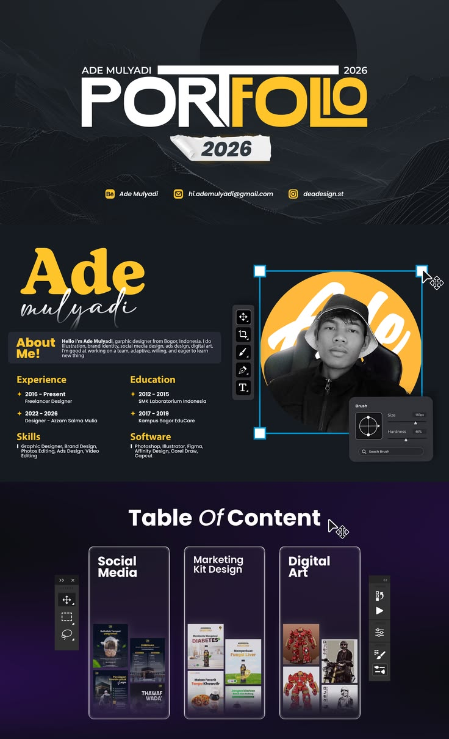
https://www.behance.net/gallery/175946865/Portfolio-Resume-2023?utm_source=Pinterest&utm_medium=organic
